Brevard Family Partnership

A Community Based Care Agency

Board Report
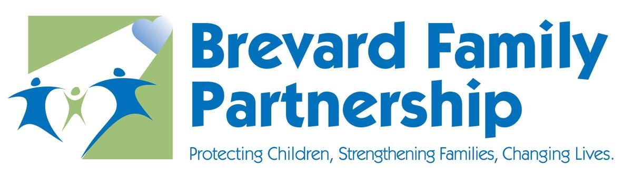

September 26, 2019

Phil Scarpelli, Chief Executive Officer

I am proud to announce the hire of Donald Johnson as our newly appointed Chief Financial Officer on Monday August 26th. Don comes to us with 13 years of experience overseeing a $364 million-dollar budget for the School Board in Milton, Vermont. He comes to us with high accolades and a wealth of knowledge working with Federal, State and Local funds and policies. He has been eager to roll up his sleeves and get to work analyzing our financial operation. I have connected him with the CFOs of our CBC counterparts to familiarize him with the child welfare system and lessons learned. He has already proven to be a tremendous asset to our leadership team and has begun building relationships with our Executive Directors and the local leadership with the Department of Children and Families.

Even though hurricane Dorian spared Brevard County from a potentially devastating impact, our staff, from our leadership to our frontlines were simply outstanding and responsive proactively ensuring the accountability of our children and families served. In addition, the Department required daily efforts to report specific, to include but not limited to, foster parent’s hurricane preparedness plans, location of all children and the communication with our stakeholders. I was so proud of their efforts and ensured that our concerns were not only of the wellbeing of those they serve county-wide but to ensure the safety of their own families.

Florida’s Annual Child Protection Conference hosted by the Department of Children and Families was cancelled due to the pending storm and has since been rescheduled for mid-December. Should any Board member have an interest in attending the 3-day conference, or any single day, please let me know and we will make arrangements for you to attend. We will soon send out the conference schedule once the Department reposts it.

At last week’s “All Staff” meeting Mandy Allen, Lisa Rosh and Mark Goldenberg from Insperity PEO presented Brevard Family Partnership and its Family of Agencies with a 15 year milestone award for our work together with their company and further donated $7,500 and a beautiful memento. With the Board’s support, I wish to designate their charitable gift to our newly established and implemented “Road to Autonomy” program for the purpose of assisting our young adults aging out of foster care in buying their first cars.

Faith Based Initiative:

On Monday September 16^{th.} I was invited to speak to 150 Brevard County Church Leaders brought together through the coordinated efforts of the Freedom Christian Center and The Grove Church. I shared the stage with leadership from across our county representing: Adoption and Foster Care, School Partnerships, Homelessness and Hunger, at Risk Families and Neighborhood Revitalization, the Opioid Crisis and Mental Health, allowing BFP the first spot to present on Foster Care and Adoption. Afterwards, LaChrista Jones, Pastor Barry Russell with the Grove and I, lead mini-workshops to engage attendees in a closer look at opportunities for fostering and adopting Brevard’s children in need.

Innovations in Child Welfare update:

NCFIE prospective Board member Nick Intintolo presently serves as an innovation and transformation leader advising the Florida DCF Secretary and Chief Innovation Officer with executing its system-wide transformation by engaging business users, partners and executive leadership to develop measurable gains in practice policy, performance and productivity modernization; allowing the agency to both innovate and expand on evidence based practices that are aligned with The Department of Children and Families. The Board Recruitment Committee will be reviewing his candidacy immediately following the Board meeting.

Legislative Update:

Recently Jim Carlson and I had the privilege to meet with Senator Tom Wright here in Brevard County at his local Office. With him was his legislative aide who took copious notes for nearly a one-hour discussion focused on BFP’s mission and impact and our ongoing efforts to replicate our CARES model. Senator Wright has agreed to support a Bill that will include language and funds for additional replication sites throughout Florida. In addition, we followed up with discussions Children’s Network of Southwest Florida and the Sarasota Family YMCA Inc., both of whom are interested in potentially integrating CARES into their systems of care. Finally, this week I have the privilege to speak to our local delegation promoting the good work of BFP and its Family of Agencies while further highlighting our contribution to our CBC cohorts reminding the delegation of our locally successful CARES program and that of the replication models in Volusia and Flagler counties and the opportunity to further share this evidenced-based model in Sarasota and Fort Myers.

NCFIE:

Dr. Patricia Nellius continues to efficiently lead the consultative oversight and implementation of the ResWrap and CARES models in Hillsborough county with the Eckerd Connects’ CBC. The following is a brief on the replication contracts in Hillsborough County:

ResWrap (Residential Wraparound)
- We have convened 6 ResWrap Implementation Team conference calls
- Established the Core and Implementation Leadership Team members
- Devised the draft implementation plan and timeline
- Are in the process of identifying the National Wraparound certification trainees who will attend the November National Training in Melbourne Beach.
  - The cost of the registration and training are covered by the contract- $2,200 per person. However:
  - The cost of the meals, travel and hotel will need to be covered by the participating agencies.
- Have received approval to delay C-6 implementation until January
- Are reviewing and finalizing the job descriptions
- We are in the process of defining the profile of the population to be served
- An impending site visit is scheduled for October
CARES replication
- We have convened 6 Implementation Team conference calls
- Established the Core Leadership Team comprised of Eckerd, NCFIE, GCJFS Safe at Home and BAYS staff members
- Developed the draft implementation plan and timeline
- Reviewing and finalizing the draft Job descriptions
- Developed and submitted the draft Self-Assessment
- We are in the process of identifying the National Certification Trainees and determining the date, time and location
- We are in the process of defining the profile of the population to be served

Respectfully Submitted,

Phil Scarpelli
Chief Executive Officer

