Brevard Family Partnership

A Community Based Care Agency

Board Report
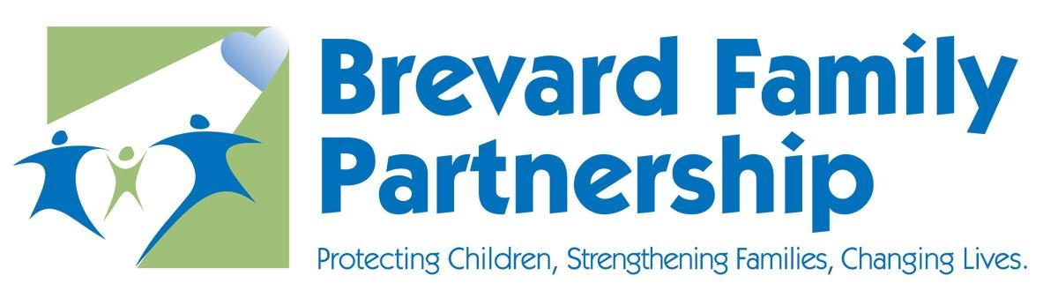

September 19, 2019
Valerie Holmes, PhD(c)
Executive Director

I am pleased to share several key accomplishment(s) that occurred during the last month. Dr. Bennett, Licensed Psychologist, provided Self-Care Trainings throughout the BFP FOA to all staff. Dr. Bennett also conducted small leadership groups and received feedback that improved communication between BFP FOA has been observed and self-care initiatives have been well received. Wellness initiatives have been added into the Strategic Plan. Some recommendations include the addition of self-care plans for all staff, adding mental health days, and ongoing training to address vicarious traumatization, burn out, and secondary traumatic stress.

BFP executed an MOU with the Brevard County Housing Authority and the Cocoa Housing Authority for the Foster Youth to Independence (FYI) initiative. HUD will provide Tenant Protection Vouchers (TPVs) for eligible youth. FYI is a new program offering housing assistance and supportive services to young people with a child welfare history who are at-risk-of or experiencing homelessness. FYI provides a new opportunity for local public housing authorities (PHAs) that do not participate in HUD’s Family Unification Program (FUP) to request Tenant Protection Vouchers (TPV), a tenant-based housing voucher, for eligible young people ages 18-24. BPF will now have access to 50 vouchers. Housing assistance will be available to youth for up to 36 months. Youth eligibility criteria includes at least 18 and not more than 24 years of age, active in Extended Foster Care, P Postsecondary Education Services and Support (PESS), or after care and/or left foster care or will leave within last 90 days, and homeless or at risk of homelessness.

BFP is continuing to increase the number of Level 1 foster homes; there are 122 application in process which represents 28% of the total caregivers who are relative/fictive kin. The goal is to reach 40% by December 31. Excellent progress is being made by Family Allies and Brevard C.A.R.E.S. in updating Safety Plans; current performance is 88.5%. Both of these activities are part of the Path Forward initiative and are methods to draw down Title IV E funding.

BFP FOA is continuing concerted efforts to improve performance on the DCF contract measures in which BFP is not meeting target (four measures). A Data Analysis Workgroup has been formed with cross representation from the FOA and System of Care. A team of two champions has been assigned to each measure. The champions are taking the lead on developing the work plan to create a “script” for improvement and to support implementation of action steps. The workplans outline action steps, responsibilities, timeline, resources, barriers, and communication plans. Unit level and worker level analysis is also being conducted. The group is convening monthly.

Registration is now open for the Lip Sync Battle at www.brevardfp.org/gala. BFP sent social media and email blasts for ticket sales and the event has been featured on Facebook for several months. Eight teams are signed up to compete: Community Credit Union, Florida Institute of Technology, Dr. Johnson from Health First, Junior League, Roy Allen, Family Allies, C.A.R.E.S., and Catherine Wright’s team. Currently, $13,500 has been received in pledged funds and 50 tickets have been sold (including those that come with the sponsorships).

Respectfully Submitted,
Valerie Holmes PhD(c)
Executive Director

