Brevard Family Partnership

A Community Based Care Agency

Board Report
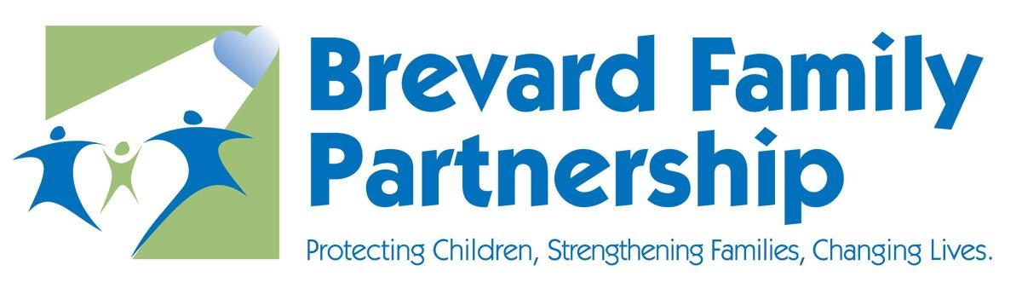

December 14, 2023

Phil Scarpelli, Chief Executive Officer

Key accomplishments

- CBCWNS Symposium (Dallas) – Brevard Family Partnership was adopted into the inaugural formation of this child welfare national alliance as a founding member. In addition, I have been elected as one of the original Board members in conjunction with 5 other Florida Community Based Care Lead Agencies. Together we are going to lead a national movement sharing history, experiences and best practices in serving children and families entering and exiting the formal child welfare system. One of our first agenda items is to develop a leadership track as a resource to the industry for the recruitment, selection, training and support of future leaders in child welfare across America.

- Statewide Faith and Community Call with LT. Governor Nuῆez – I participated a statewide virtual gathering of child welfare leaders, agencies and stakeholders to both hear and support our Lieutenant Governor Nunez’s agenda to continue engaging faith communities in the efforts lead by community based care organizations in serving our most vulnerable children and families. BFP and its Family of agencies are proud of our historical and ongoing relationships with many churches throughout Brevard County. They are becoming more intimately involved in supporting family visitation, agency events, and investment in our “Open Tables” (model program for family intervention) promoting transformation changes in the lives of our families associated with the support and contributions from those within their very own communities.

- Delegation Meeting – Port Canaveral – This past month I participated in the gathering of our local delegates whereby they shared their individual and collective agenda for the coming year. It reflected a response of our ongoing efforts to educate them of the private sectors efforts in diverting thousands of families to falling deeper into the social welfare system and the efforts responsible for the diversion and prevention of the removal of children in the child welfare system. This level of communication and social awareness is something requiring perpetual engagement and actions support by our delegation.

- Foundation Golf Outing – Our Annual golf tournament was a tremendous success in getting the community more familiar with who and what we do in protecting children, strengthening families and impacting lives of those involved in the formal system and for those leading down a path of greater need for support and guidance toward sustainability and self-sufficiency. Our revenue generated has topped previous years and we look forward to keeping this trend alive in the years ahead.

- Meeting with Secretary Harris – I recently was privileged to have a one-on-one discussion with our DCF Secretary to share more about what BFP/FOA have been doing for Brevard’s children and families and to reinforce our partnership with the Department knowing her philosophy of a “One Florida,” a system that builds upon a partnership with one aligned mission that requires the leveraging of resources, joint strategies, and ongoing communication in an effort to optimize our relationships’ impact.

- Celebration of Adoption – Last, but certainly not the least, our annual Celebration of Adoption whereby 12 children who were adopted into 10 “forever families” was a tremendous success. Our venue at Space Coast Stadium if a one of a kind, for which many have followed across Florida. We wish to thank the community at large, our staff, our partnered agencies, the judiciary, the Department of Children and Families, but most of all, our foster and adoptive families who give selflessly and take our community’s children into their families loving them and accepting them unconditionally

- We have re-negotiated the renewal of our Professional Employer Organization agreement with Insperity, successfully preventing an increase in the cost of healthcare to our workforce, for the coming year. Board Approval is required to move forward with the renewal.

Upcoming Events

- The board officers and I have decided to move the January 25, 2024 Annual Board Retreat/Board Business Meeting to May 23, 2024 in alignment with the ITN announcement and the strategic planning process.

Respectfully Submitted,

Phil Scarpelli
President and Chief Executive Officer

