Brevard Family Partnership

A Community Based Care Agency

Board Report
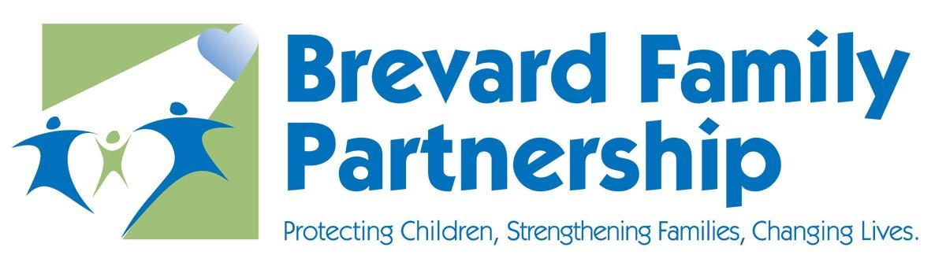

March 28, 2024

Phil Scarpelli, President and Chief Executive Officer

- ITN Preparation and Submittal and Award -We continue to be in daily meetings with the Department and Embrace Families’ staff. We are having a deep dive discussion in preparation for transitioning our oversight of a four county-wide system of care and nearly doubling our workforce. The Department has been instrumental in co-facilitating meetings across all domains but not limited to staff onboarding, system of care design, organizational chart, community engagement, case management and provider contracts, community stakeholders and Department oversight of the Lead Agency contract.

- NCFIE Strategic Planning Meeting (update) - The NCFIE team and BFP leadership team spent a half day discussing both the status of its operations, relationships across the US and opportunities to expand a service array of training on our high-fidelity wraparound model. We discussed how to best leverage its workforce in accordance with the individual expertise each member possesses. We discussed ways to expand our repertoire of talent through consultancy, replication, and then pursuit of additional grants in order to expand our reach across the social welfare industry.

- Rally in Tally – I went to Tallahassee during session to engage in discussions relative to the challenges faced across our industry. I worked worth our lobbyist to further educate in an effort to influence policy makers on the growing needs within child welfare while celebrating the impact community-based care has had over the past 20 years. Our legislators need to know that Florida leads the nation in so many outcomes, from adoptions, reunifications, graduation rates,

- FCC Update – The Florida Coalition for Children continues to advocate language proposed and provide well document explaining their implications on our contractual arrangement with the Department and the delivery of care and responsibilities in our contracts. We have numerous subcommittees working on data analysis, system and capacity needs to better serve our children and families, the cost of doing business, and the challenges faced but a system that continues to face over-regulation when in fact needs more resources and adequate funding.

- Dissolution of FA and CARES – We formally dissolved the legal entities of Brevard CARES and Families at the direction of the Department and have adopted them as divisions of Brevard Family Partnership. They will remain intact with all staff accounted for and their program delivery will remain serving our most vulnerable children and families successfully as they have for the past two decades.

- TV Interview – I had the honor of being interviewed on Channel 9 local news about the award of our lead agency contract soon to serve Orange, Osceola, Seminole and Brevard counties. Our mission is to share the positive work we have been doing in Brevard to our three neighboring counties. I spoke about how we will leverage the talent and resources among the 4 counties to better serve our central Florida children and their Families.

- Transition Team Meetings Update (DCF/EF) – since the announcement of our new contract, we have been working relentlessly with the Department and Embrace Families’ staff in preparation for the transition in these next few months. Although change can often be difficult, it has bee truly wonderful how the three entities have come together sharing one mission in building a single system of care from lessons learned and best practices established.

Respectfully Submitted,

Phil Scarpelli
President and Chief Executive Officer

