Board Report
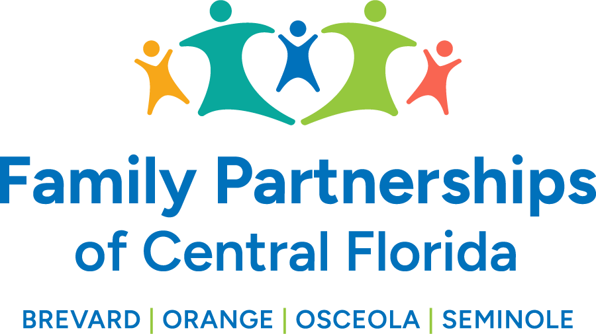
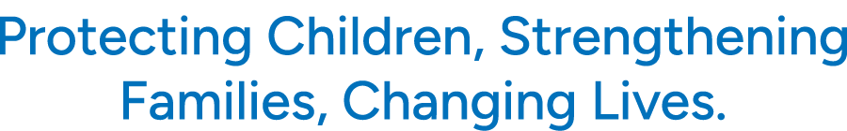

)

May 23, 2024
Phil Scarpelli, President and Chief Executive Officer

Summary

- As we wrap up the month of April, I am proud to report that the transition to our new contract encompassing our growing workforce, our greater geographic coverage area, and our 4 county contract with DCF has progressed very well. Many thanks go to our transition teams from both BFP and Embrace Families in concert with the supports provide by the Department of Children and Families and our fellow Community Based Care organizations. Leadership has diligently engaged our community stakeholders and attended numerous community meetings sharing oversight and building new relationships and re-establishing older ones. The communities’ receptivity and support has been quite humbling. The Department has been very pleased with the seamless transition and the assertiveness of reassuring the workforce and our partner agencies that business has not been interrupted. I can’t express how grateful and proud I am of all the nearly 500 employees who now represent Family Partnerships of Central Florida.

- We have successfully rebranded our name and logo while retaining our organization’s original tag line, “Protecting Children, Strengthening Families and Changing Lives.” As you can see by the cover of this report our new graphic retains some of our original color scheme and visual symbolism with an expanded reflection of a larger family. We have already received many accolades and appreciation from our cohorts and the Department for this new brand.

- CBCWNS Symposium (Tucson) – Last time I presented on our new national affiliation with the National Center on Community Based Child Welfare, I mentioned that we have become a chartered member and hold an inaugural seat at their Board of Directors. There are nearly 20 states now coming together to share the trials and tribulations of child welfare practices and experiences from coast to coast. Our commitment is to be a part of a national movement that will ensure that lessons learned, and successes accomplished will forever change the landscape of Community Based Care across our country.

- I attended a statewide conference entitled Positive Pathways on behalf of our work supporting youth in preparation for their pursuit of secondary education. Our system of care is highly regarded as a state leader for the engagement of our youth and the support of their “road to independence” valuing education as a key to success. I was asked to offer words of encouragement so that communities and agencies serving children and youth through the foster care system step up to help them prepare for college and careers. Positive Pathways earned a statewide contract under the Department and have been charged with elevating the focus and the engagement of youth, agencies and communities to rally, mentor and support our youth who are aging out to the system. Florida leads the nation in the number of youth who graduate high school and will soon lead the nation for young adults with lived experience graduate from colleges.

- It has been an absolute pleasure meeting legislators from across our new counties sharing the news of our expanded contract encompassing both Circuits 9 and 18. Meetings with Representatives David Smith and Anna Eskamani were both stimulating and hopeful. Both delegates had an infinity for championing the children in the system and had an appreciation of community-based care. I will work to continue building and leveraging these individuals as voices in Tallahassee that will focus on children as a priority and the funds and policies need to support our efforts locally.

Updates
- We hope you are excited about our upcoming Board Retreat to reflect on the past, celebrate the present and plan for the future. We have invited a special consultant who is an author, a well-regarded leader and visionary to join us as a facilitator on the morning of our annual retreat, Thursday May 23rd.

Respectfully Submitted,
Phil Scarpelli, President and Chief Executive Officer

