Board Report
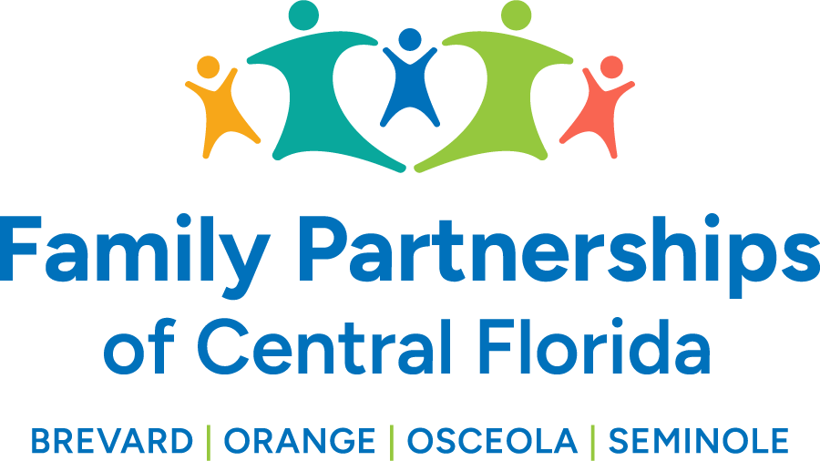


)

July 27, 2024
Phil Scarpelli, President and Chief Executive Officer

Summary

- Transition Update: I have connected with all the major Law Enforcement Leadership in the four counties; with all the Chairs of their respective county Alliances, additional key faith leaders, the delegation now encompassing our expanded scope of service. The general theme is one of elation that we are here now with the hope of turning things around and building stronger relationships while celebrating the uniqueness each county brings to our system of care.

- Workforce Reduction: In a strong effort to balance our budget the two primary areas of impact have been with staff and with our subrecipient partner agencies. The reduction exercise impacted 14 positions of which 10 positions were retained with newly defined roles. The Case Management Organizations contributed to a 20% budgetary decrease and their efforts were to be praised for both their understanding and diligence towards achieving their goals.

- Budget Update: We continue to do a deep dive with the confidence of attaining a balanced budget without compromise to the goal serving our children and families seamlessly and with the same standard of excellence. We have been transparent and with both the communication and consistency of messaging as to assure the stability of our organization and commitment to prevent the exercise from being necessary down the road.

- Employee Satisfaction Survey Results: Cyndi Hernandez, our HR Director will present a summary of this past years staff surveys. I was pleased to see the high level of job satisfaction and the high rate of retention as being two key indicators that our team and board should be proud.

- Latest DCF Updates: Our agency continues to contribute to an ongoing evaluation with KPMG, consulting firm hired by DCF, to evaluate the “cost of doing business as a lead agency” by focusing on actuarial financial data as reported by the 16 agencies that currently have CBC contracts. We are optimistic that this will be enlightening and encouraging as such a time it is to be presented to our legislature this coming session.

- Communication/PR/Marketing Update: With have finalized our “new brand” and working both internally and externally with our marketing agency, Rock Paper Simple, a local provider we have used for the last few years. We have participated in several community events with our new banner, new name, broader identity capturing the larger portion of central Florida.

- FCC Conference Update: This year’s conference had a record-breaking attendance. Annually, thought leaders gather at this event to share the innovations and successes of community-based care. The Secretary of DCF attended and addressed the audience with a message of appreciation, recognition and commitment of the Department’s partnership particularly with Lead Agencies and Provider Agencies working with children and families formerly in the child welfare system. DCF continues to endorse both the Hope Navigators throughout the state and the Care Portals both of which are to be augmenting the diversionary efforts that has reduced the number of families getting involved judicially in the child welfare system.

Updates

- Sean Kostelnik, Chair of our Foundations Advisory Board, is spearheading an innovative strategy of engaging an expanded new audience promoting our mission and sponsored by his own agency Wood River Studio and a developer of new homes in the Viera area. Stay tuned, as this is going to be a new approach at launching our philanthropic initiative for community awareness, engagement and donor relationship building.

Respectfully Submitted,

Phil Scarpelli, President and Chief Executive Officer

