Board Report
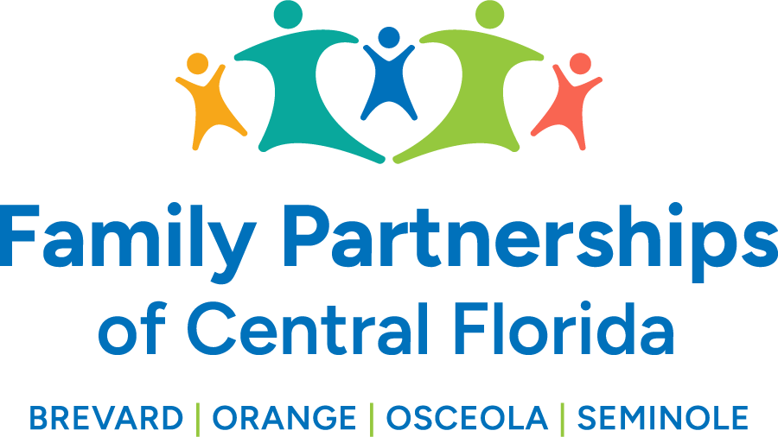


)

January 23, 2025
Phil Scarpelli, President and Chief Executive Officer

Summary

- FCC Updates – This past week the Senate Subcommittee of Children and Families and Elder affairs convened a hearing to address the new Community Based Care funding model being presented by the Department of Children and Families. Representation from our member organization, the Florida Coalition for Children spoke as well to committee members. There were obvious points and counterpoints presented by each party, nevertheless, it was more information our Senators needed to know in order to move forward with the new proposed model, deny it, or in fact, request modifications. The Senate responded on more than one occasion that they were concerned about the reported, and documented, projected budgets of several CBCs who will be running deficits this year. The Department “stated” that they will keep us whole, “for allowable expenditures” they currently exceed their allocations.

- Magistrate/Legislative Updates – I met with Magistrate Lisa Bedwell affiliated with the Orange County Circuit Court. We discussed her observations of our dependency case management teams particularly as they present in her courtroom. She gave a balanced perspective regarding their strengths, weaknesses and opportunities for continued growth. She indicated the importance of pre-hearing discussions with case workers and Children’s Legal Services (DCF) to help with their diligent efforts preparing for providing the courts with comprehensive reports and accountability and timeliness of their appearance and contributions to their cases.

- DCF Updates – This week we’ve met with the Department’s leadership team’s both Regionally and Statewide to discuss a pilot program for which we were selected to do a drill down on performance metrics in the spirit of partnership. They articulated a strong desire to be a part of some of the challenges in working with both our consumers and stakeholders. We also met with the Secretary and her of finance to better understand our financial state of affairs since the transition, in hopes to obtain clear guidance as to they plans are keeping us “whole.”

- Florida’s Children First – The Advocates for Children Awards had their annual event recognizing youth statewide for their advancements and contributions to youth “voice and choice” and one of our very own Brevard Youth Leadership Council members was recognized for his personal growth and development as a youth leader. He recognized BFP as a main contributor for his success through mentorship and organizational guidance. He represents one of several youth who represent our system of care that, collectively, they lead the state in Councils that have had the greatest impact!

- Holiday Gift Drives – Another year and our community has answered our prayers for their contribution to Christmas gift giving. The Churches, private donors, Health First and so many more have gone above and beyond to ensure Christmas for our children in care would be special. A major shoutout for our staff who dedicated many additional hours, beyond their normal roles, to ensure every child received gifts timely!

- IT Selection Update – After a round of interviews between three competitive providers for “IT Services,” ITech has been awarded the contract to serve FPOCF’s 4 counties. They will be working under the guidance of our internal MIS Department to ensure security, hardware, software, technical assistance and more for our workforce of 420+ employees!

Updates

- Just a reminder to existing Board members that if you happen to know individuals who may be an ideal fit to join our Governance Board, please reach out to me to make a warm hand-off or to join me in engaging such individuals in the prospect of joining our efforts in leading this organization’s mission, now in four counties.

Respectfully Submitted,
Phil Scarpelli, President and Chief Executive Officer

