Board Report
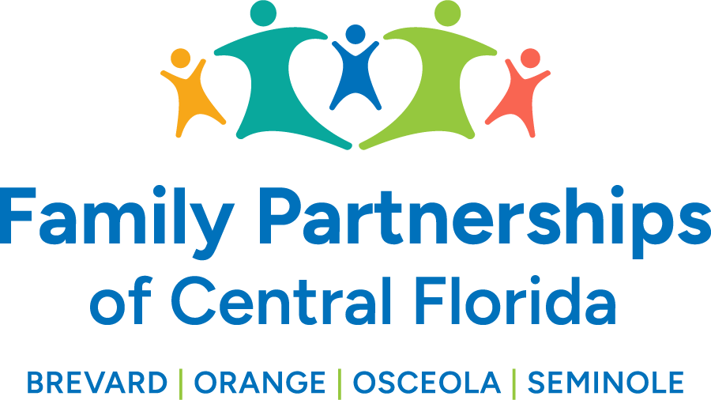
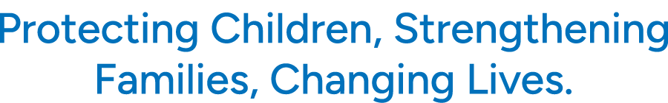

)

December 12, 2024
Phil Scarpelli, President and Chief Executive Officer

Summary

- COA News – We received following from a representative of the Council on Accreditation:
On behalf of the Council on Accreditation (COA), I am delighted to inform you that the interim review of Community Based Care of Brevard, Inc. dba Family Partnerships of Central Florida has been approved. In addition, Community Based Care of Brevard, Inc. dba Family Partnerships of Central Florida was expedited through the Pre-Commission Review Report (PCR) process as a result of not receiving any out of compliance ratings in any of the fundamental practice or core standards. Congratulations on this amazing achievement.
- State Updates – We, in concert with the Florida Coalition for Children, have been working with the Department of Children and Families and the firm KPMG who contracted to evaluate and recommend a funding model for the future of Community Based Care in Florida (aka Lead Agencies). Among numerous topics that have been on the table has been the comparing of a cost model verses an expenditure model; the limited funds in the Risk Pool ($3 million); and whether there will be funds set forth in the “Back of the Bill” allocation. A decision and proposal by the Department must be made by mid-December at the direction of the legislature. We have put in our application for the Risk Pool and have further provided a detailed budget forecast for the Department.
- New Legal Counsel – John Hubbard has been a longstanding attorney with DCF and the GAL Program here in Florida. He is extremely knowledgeable about child welfare from several lenses and is a huge advocate for championing the safety, well-being and permanency of our children and youth. He is a kind and caring individual who advocates strongly for those who have no voice. He will be a wonderful asset to our C-Suite. We will subsequently celebrate Kelly Swartz’s history of serving children and families as she prepares her transition to a semi-retiring status, but we are fortunate that she will remain contractually tied to our mission as she helps drive adoptions for Brevard and Seminole counties into the future.
- Update on repairs at ASC – Since Hurricane Milton, we have removed ourselves from our administrative office in Maitland due to flooding. Our team has worked aggressively with the landlord who has done a thorough job renovating and restoring our operations which is projected for December 11.
- FIT Presentation – I recently lectured to undergraduate and graduate students majoring in psychology, sociology, and criminal justice at Florida Tech. These are wonderful platforms for awareness of the state of child welfare in Florida and career opportunities in a variety of disciplines throughout our system of care. The student body was very engaged and responsive, wanting to know more about the nuances of children in foster care and their respective journey.
- Insperity Renewal and 20-yr presentation – Our Professional Employer Organization and partner, Insperity recently awarded Family Partnerships of Central Florida with a 20-Year partnership award and a donation of $7,000! They have been an amazing partner working with refining services to help strengthen our HR practices, mid-level leadership development, workplace culture, not to mention, helping us control the rising cost of healthcare while providing excellent benefit packages for our staff and their families.
- C9 Alliance Meeting – Seminole county’s children alliance has championed the engagement of the Chairpersons of each counties’ alliances with initial discussions sharing history, current focus, and future opportunities. I have been Chairing Brevard county and also participate in the statewide alliance membership called, The Collective; our four counties feel in many ways that we are leading the movement of leveraging resources and defining a more acute focus of impact into the future not only serving our most vulnerable children but sharing best practices in community engagement and community contributions to our system of care.
- Adoption Events – Once again we celebrated in November or National Adoption Day with four individual county adoptions over three days. I had the privilege of speaking to those in attendance at our very own Brevard Space Coast Stadium. Joining me in a message of unity, collaboration and heartfelt congratulation was Secretary Shevaun Harris, DCF, and CEO Mike DiBrizzi, Camelot Community Care, to all our children and youth officially coming together with their forever families.
- Our new Tri-county Foster Parent Association – Our team continues to unite and build strength on the experiences of all four counties’ foster families leverages better practices and the sharing of the trials and tribulations of their fostering journey. We received much positive feedback from the fostering community reflecting much pride in their individual counties and yet recognizing the significance of representing one of the largest fostering communities in our state.

Updates

- Just a reminder to existing Board members that if you happen to know individuals who may be an ideal fit to join our Governance Board, please reach out to me to make a warm hand-off or to join me in engaging such individuals in the prospect of joining our efforts in leading this organization’s mission, now in four counties.

Respectfully Submitted,
Phil Scarpelli, President and Chief Executive Officer

