Family Partnerships of Central Florida

A Community-Based Care Agency

Board Report
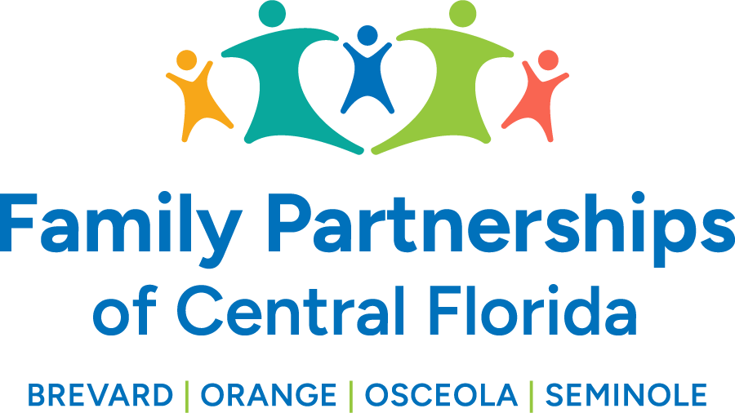
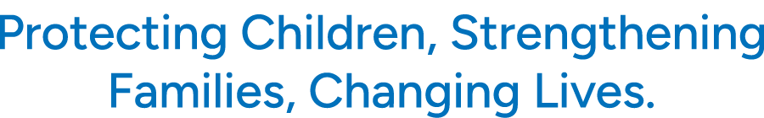

March 27, 2025

Phil Scarpelli, Chief Executive Officer

Summary

- Rally in Tally – I had a wonderful meeting with the incoming Secretary, Taylor Hatch, while in Tallahassee. I am very optimistic and energized by the opportunity to build a new relationship within a year that we have transformed our organization. She is familiar with our acquiring the additional counties and looks forward to partnering with us to better serve our most vulnerable children and families. I hope to leverage her experience and expertise in serving children with developmental disabilities who enter into the child welfare arena.

- Risk Pool Update – We received good news that the Department did approve $630,656 of the $3.5 million dollar Risk Pool funds. There were six other lead agencies asking for funds as well, so we felt that the amount allocated to us is what was reasonably expected. We now wait for additional dollars to help offset our projects from either the Back of the Bill or funds from the Department’s general revenue. I feel optimistic that the Department will pull through for us. In the meantime, since the legislators did not approve a new funding model this year, it will be incumbent upon us to work closely with the Office of Financial Management within DCF to provide an accurate account of allowable expense for which they assured us “being made whole.”

- Forever Families Interview – I was recently interviewed about my journey and experience serving children and families in crisis and my perspectives on leading a workforce across four counties. This was simply a wonderful opportunity to share my “why” with a potentially varied audience who may may be the caseworkers of tomorrow, the foster and/or adoptive families for our children and youth, or the leaders of future organizations such as FPCOF.

- GJ514 Contract Site Visit Update - DCF had their first on-site review at our Central Care Center this past week whereby they interviewed the Executive Leadership Team, Caseworker and consumers. Their summary was quite flattering and reflected on our culture and performance and yet left us with recommendations relative to the acknowledgement that our workforce want to see their wages impacted favorably. This is something that continues to be a major priority for our advocacy in Tallahassee during session!

- Building Updates – It is continually an important exercise to meet and discuss with our landlords regarding the state of our facilities in the best interest of our growing workforce. I met with the landlord of our Orlando facility on Pelee Street to ensure he was on top of the up-keep of that site. The conversation was very productive and wrapped up with his interest in supporting our upcoming Golf Tournament!

- OHU Annual Board Retreat and Strategy Summit – I was invited to attend one of our case management agency’s Board Retreats. It was a wonderful evening to mingle with Board members from across the country and with those representing OHU’s Florida operations. We share the success built on the relationships of two organizations with a rich history in child welfare. I was also able to share my experiences during my earlier career with OHU and my fond memories building programs and leading their workforce over 15 years ago.

Updates

- Just a reminder to existing Board Directors that if you happen to know individuals who may be an ideal fit to join our Governance Board, please reach out to me to make a warm hand-off or join me in engaging such individuals in the prospect of joining our efforts in leading this organization’s mission, now in four counties.
- Remember to guide prospective golfers and sponsors to our website to sign up for and/or contribute to our Annual Golf Tournament in April. Go to our website for all the details!

Respectfully Submitted,

Phil Scarpelli
Chief Executive Officer

