Family Partnerships of Central Florida

A Community-Based Care Agency

Board Report
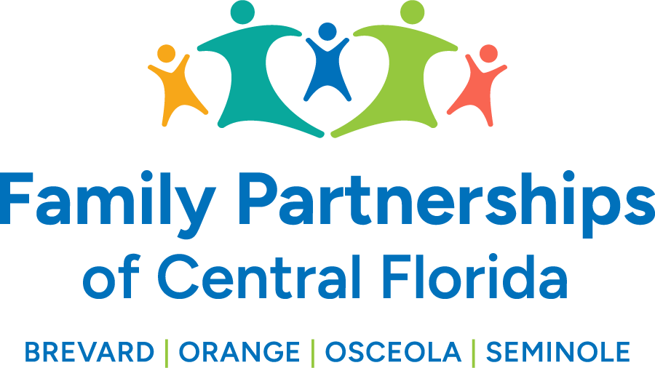
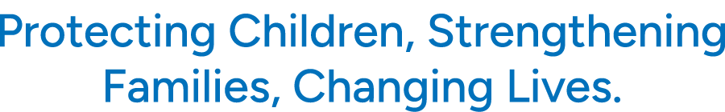

April 27, 2025

Phil Scarpelli, Chief Executive Officer

Summary

- CAPTF Events around the counties – Attended numerous Pinwheel plantings around our four counties over the past two weeks. Joined our partner agencies, Sheriff’s Department, Children Advocacy Centers, and other State agencies to recognize Child Abuse Prevention Awareness Month. The common theme was that preventing child abuse is the responsibility of all of us and together we can and will unite and leverage our resources in order to protect our children strengthen their families and to lead them towards resilience.

- State Funds - We remain in a holding pattern with regards to the Risk Pool funds, Family First Transition Funds, and our own contract transition funds since the acquiring of our expanded scope of service. There is much going on in Tallahassee unfortunately and likely distracting the process. We communicate regularly with DCF Head Quarters reminding them of the challenges we face in spite of the vigilance to our unwavering efforts to continue providing our continuum of services to our most vulnerable children and their families.

- Back to God Radio for WTLN Interview – I recently had the privilege to speak on a half hour radio show on both the AM and FM dials. Joining me was our very own Hunter Ballou to share April Events to include the very successful Golf tournament. The radio spotlight focuses on our mission, its impact and a “shout out” for interested families to foster and adopt our many children available to connect with loving families.

- Citizen Review Panel – There has been some discussions in Brevard County about instituting citizen review panels. The purpose of citizen review panels in Florida is to review child cases, address the safety and appropriateness of child placement, identify barriers to permanency, and make recommendations to the court. These panels are intended to play an integral role in ensuring that Florida meets its goals of protecting children from abuse and neglect.

- DCF Updates – We have a new DCF Secretary, Taylor Hatch, who came from the Agency for Persons with Disabilities. Secretary Hatch had previously worked under Secretary Shevaun Harris and is familiar with the Child Welfare System. I had the privilege to have a one on one discussion with Secretary Hatch while recently visiting Tallahassee.

- Golf Outing – The golf tournament this past week at Eagles Creek Golf Club at Lake Nona was a wonderful event. The weather was perfect for our golfers and our staff showed up in good numbers to engage participants, sponsors and supportive community members. We are still tallying up the numbers as we thank all the donors for their generosity!

- John Watson Interview – John is a young man who aged out of foster care, now 24 years old, with his bachelor’s degree, and currently enrolled in graduate school. One of his projects for this semester is to Interview a CEO and Chairman of a non-profit board, So Eric Austin spent an hour engaging in a very intimate dialogue regarding the oversight of such a large and impactful organization. John came prepared to discussed everything from ethics to philosophy, to management to processes. I continue to mentor this fine young man who has been a successful advocate and champion for children and youth journeying through the foster care system.

Updates

- Just a reminder to existing Board Directors that if you happen to know individuals who may be an ideal fit to join our Governance Board, please reach out to me to make a warm hand-off or join me in engaging such individuals in the prospect of joining our efforts in leading this organization’s mission, now in four counties.

Respectfully Submitted,

Phil Scarpelli
Chief Executive Officer

