\

Family Partnerships of Central Florida

A Community-Based Care Agency

Board Report
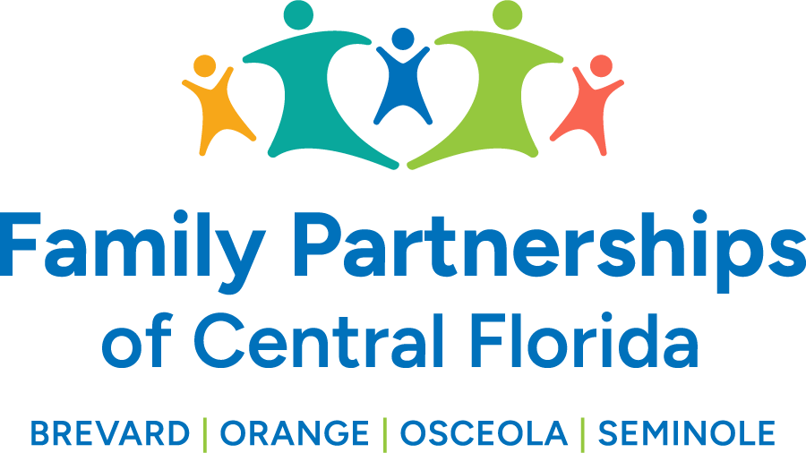


May 22, 2025

Phil Scarpelli, Chief Executive Officer

Summary

- Capernaum Project - FPOCF is working on a Memorandum of Understanding to establish a collaborative partnership among Wings of Grace Ministries, Family Partnerships of Central Florida, the Housing Authority of Brevard County, and WAYS for Life to launch and manage the 24-unit affordable housing initiative designed to provide safe, stable, and supportive housing for at-risk youth, including but not limited to, youth aging out of foster care in central Florida.

- Community Credit Union and FPOCF are exploring a collaborative partnership to support our Keys to Independence (K2I) program, which helps teens (18 – 21) in foster care or experiencing homelessness obtain the resources they need to afford a car and build a path toward a brighter future. Their goal is to create accessible auto loan opportunities for these young adults while providing financial support to our organization to help expand this life-changing initiative.

- Insperity Focus Workgroup – Insperity has agreed to lead a focus group that brings together FPOCF staff, CARES Advisory Group members, and community representatives. This session aims to explore how we can create different community boards that can work together, gathering diverse input to help design a more effective and inclusive structure in support of our mission. Resulting in the collaboration of common goals, resource sharing, community-wide strategy, stronger advocacy, improved communication, innovation, and idea sharing, and building trust and unity

- Interviews have been completed for a Communications/PR person, pending the offer and acceptance.

- Risk Pool/Back of Bill – We’ve been informed that funding from our Risk Pool/BOB request through the Department of Children and Families (DCF) is expected to be approved and added to our forthcoming funds. This additional support will help reduce our projected deficit and strengthen our financial position moving forward. The re-procurement of the Safe at Home and case management contracts has resulted in leaner, more efficient contracts. These changes have been helpful in managing the projected deficit and are expected to lead to cost savings moving forward.

- WonderWorks, an indoor interactive amusement park, welcomed foster parents and children this past weekend for Foster Parent Appreciation Week. Everyone enjoyed a fun day of hands-on exhibits and food.

Updates

- Just a reminder to existing Board Directors that if you happen to know individuals who may be an ideal fit to join our Governance Board, please reach out to me to make a warm hand-off or join me in engaging such individuals in the prospect of joining our efforts in leading this organization’s mission, now in four counties.

Respectfully Submitted,

Phil Scarpelli
Chief Executive Officer

