Family Partnerships of Central Florida

A Community-Based Care Agency

Board Report
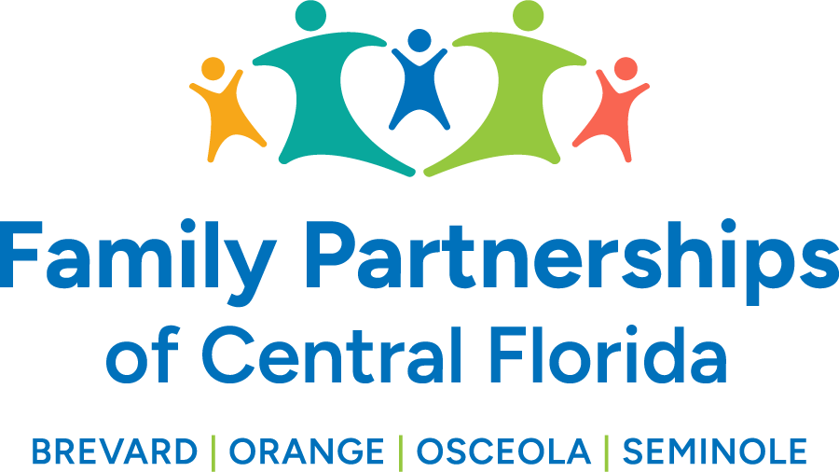


June 26, 2025

Phil Scarpelli, President and Chief Executive Officer

Summary

- Capernaum Project Update – FPOCF is has now engaged in a Memorandum of Understanding to establish a collaborative partnership among Wings of Grace Ministries, Family Partnerships of Central Florida, the Housing Authority of Brevard County, and WAYS for Life to launch and manage the 24-unit affordable housing initiative designed to provide safe, stable, and supportive housing for at-risk youth, including but not limited to, youth aging out of foster care in Central Florida. Our primary role will be to provide a pipeline of eligible young adults who have either aged out, or who aging out of foster and do not have a place to live. This opportunity comes with additional resources supporting the pursuit of employment, education and life skills training.

- Property Updates – Our facilities management team continue to maintain a pulse on our current footprint throughout the four counties ensuring that our staff’s workplace is safe, functional and with adequate accommodations. We are working with our current landlords to have certain needs met while exploring options post term of our leases for consolidation and/or relocation to create efficiencies and functionality that are appropriate for our growing operation.

- Insperity Focus Workgroup – We have established our agenda and secured trained facilitators to lead our Advisory Board/Council focus group. We have a diverse roster of attendees that represent staff, board members, community members and prospective advisory board directors with a focus on establishing: purpose, structure and member profiles to pursue. They and our current lobbyist will be the primary drivers to engage prospective members to become our inaugural four county advisors.

- Meeting w/Secretary Hatch – The C-Suite engaged the incoming Secretary of the Department of Children Families in an introductory conversation with their Statewide Leadership Team. Our agenda was to share the successes of our transition, the work we do in partnership with Department staff at the local level and the excellent working relationship we exercise with her co-teams on improving performance outcomes for our children and families. Secretary Hatch appeared delighted to hear how our new organization is developing. We certainly left the meeting on a high note but didn’t neglect the opportunity to advocate for a status on funds forthcoming that have been supported by the Senate Appropriations Committee.

- Florida FAPA – FPOCF supported the statewide annual Foster and Adoptive Family Association meeting at the DoubleTree Conference center in Orlando. It was a wonderful opportunity for our foster parents to network and receive training and exposure to resources designed to assist them in working with our kids, particularly with those with special needs.

- Youth Leadership Event – We hosted a Youth Leadership Workshop at our Maitland office where I was privileged to speak to a dozen of our youth who are, or have been, in foster care about the importance and impact of advocacy. Even by their own testimonials, the morning was engaging and provoked much conversation regarding how to optimize “their story,” how to speak to a variety of audiences, and how to leave others feeling aware and motivated to want to support our youth. Lunch was provided and opportunities for the youth to share why they joined this advocacy group and why advocating is important to them.

- Reunification Event – Once again FPOCF participated in this annual event celebrating children successfully reunified with their families. The venue was “Field of Dreams” with several vendors providing food, entertainment and face painting for our children, families and staff! A special award and recognition were given to our outgoing Dependency Court Judge, Kelly McKibben, for her commitment to serving our children and families exiting the child welfare system.

Updates

- Just a reminder to existing Board Directors that if you happen to know individuals who may be an ideal fit to join our Governance Board, or future Community Advisory Boards, please reach out to me to make a warm hand-off or join me in engaging such individuals in the prospect of joining our efforts in leading this organization’s mission, now in four counties.

Respectfully Submitted,

Phil Scarpelli
President and Chief Executive Officer

