Brevard Family Partnership

A Community Based Care Agency

Board Report
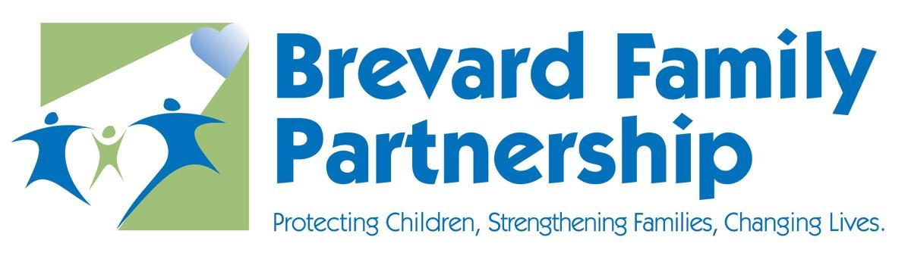

August 28, 2025
Phil Scarpelli, President and Chief Executive Officer

Summary

- Capernaum Project Update - A 24-unit apartment complex in Melbourne is now accepting eligible young adults who are aging out or have aged out of foster care. This has been a wonderful collaboration between FPOCF, Wings of Grace Ministries, Ways for Life, and a local developer. Our Independent Living Team is the primary pipeline of referrals for this initiative. Our eligible clients must be employed, enrolled in secondary educational programs, or both. There will be additional resources provided to include mentorships to ensure their success.

- Insperity Advisory Focus Group Meeting – The focus group, representing community members, board members, staff, and foster/adoptive individuals, was very productive, yielding a summary for the Board's review, previously sent. More details will follow in my presentation to the Board at our next meeting. I hope to get the Board's approval and support for the formation of local Community Advisory Boards for each of our four counties.

- Back to School Drives – Our recent Back to School Drive was a tremendous success thanks to our staff, volunteers, and members of Suntree United Methodist Church in Melbourne. Our foster children, of all ages, and their respective foster families came out to receive backpacks filled with a variety of school necessities. We had local media coverage and families interviewed to share their stories and appreciation for this generous community.

- High Acuity Workshop – Valerie Holmes and I spent an entire day up in the Panhandle at a workshop hosted by one of our fellow CBC agencies. The topic focused on children and youth with complex behavioral issues that span multiple jurisdictions. Since Florida lacks the capacity to adequately meet the needs of these youth, their families, and our systems of care, we have created a call to action that includes an economic assessment and political action planning. This group will have follow-up meetings to include organizations from across the United States.

- League of Cities – I was recently invited to speak to members of the League of Cities, Florida's membership organization, where local and state dignitaries come together to discuss communities' needs and advocate for both political and economic issues hindering the growth and resilience of our citizens. I was asked to be the Keynote speaker, where I shared our mission and stories of our children.

Updates

- Just a reminder to existing Board Directors that if you happen to know individuals who may be an ideal fit to join our Governance Board, or future Community Advisory Boards, please reach out to me to make a warm hand-off or join me in engaging such individuals in the prospect of joining our efforts in leading this organization's mission, now in four counties.

Respectfully Submitted,

Phil Scarpelli
President and Chief Executive Officer

