Family Partnerships of Central Florida

A Community-Based Care Agency

Board Report
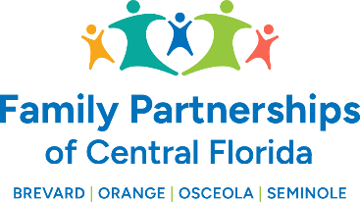
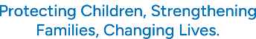

February, 26 2026

Phil Scarpelli, Chief Executive Officer

Summary

- Legislative Activities – Please click on the hyperlink report (cw_tracker_week6.html) provided by our lobbyist, Robbie Vogan.

- Monthly Podcasts – We have now produced several Podcasts hosting a variety of stakeholders, from foster/adoptive parents, donors, board members and soon, youth who have aged out of the foster care system to go onto successful careers. Please check out these videos on our website at: FamilyPartnerships.org

- Workforce Planning Updates – Our marketing team and I had a planning meeting this week to discuss strategies to market employment opportunities across our agency relative to the variety of positions. In concert with these efforts, we are planning to celebrate and profile success stories and testimonies of those who have held down positions

- Riomar Move Updates – We have conducted several meetings focused on the move of our Commerce Operation to our Riomar facility. The two primary goals were to reduce our expenses and to bring staff closer together and continue our focus on strengthening our organizational culture. We are also looking forward to expanding our business arrangement with the current Landlord at Riomar.

- Subaru Loves Event and YS Youth Summit – We recently partnered with Subaru of Sanford to host a day of giving to our foster children. Subaru has offered to give our foster kids brand new sneakers and socks while Chik-Fil-A has once again stepped up to provide our children and their families lunch!

- Health Insurance RFP Update – We are now receiving respondents to the “Request for Proposals” (RFP) for the human resources, benefits, and payroll services. We are hoping to work with a new broker who will in turn understand the need for our organization to re-evaluate the rising cost of healthcare benefits and payroll services. Such savings will be reinvested in our operations in serving children and families within our expanded footprint in Central Florida.

- CCWIS Updates – Our designated team for the “Change Management” workgroup have been diligently attending regular meetings led by the Department of Children and Families in preparation for the “go live” start date of the State’s long awaited child welfare information system.

- Golf Event Update – The team and I produced several promotional videos for our upcoming Annual Fore Our Kids Golf Tournament at Eagle Creek Golf Course in Laka Nona on April 17th. We have begun receiving sponsorships and foursomes!

Updates

- Just a reminder to existing Board Directors that if you happen to know individuals who may be an ideal fit to join our Governance Board or our Community Advisory Boards, please reach out to me to make a warm hand-off or join me in engaging such individuals in the prospect of joining our efforts in leading this organization’s mission, now in four counties.

Respectfully Submitted,

Phil Scarpelli
President and Chief Executive Officer

